**Abstract**

When developing networking services, the challenge of sharing experiences is usually a crucial point in the collaboration and development. In this new era of experience, people respond best to the engaging and immersive content. With an increasing amount of content with such interactive experiences, the question of distributing the content to various platforms arises.

WebGL and HTML5 are two common solutions to distribute the content in web browsers. The performance of the rendered content, to a considerable extent, relies on the capabilities of the receiving browser and hardware on the client side; the quality of the graphics depends on the browser’s display capabilities. That means that in order to share the content to the maximum number of users, either the shared application id defined by the lowest acceptable device, or multiple versions of the application are required to distribute to different platforms.

The Unreal Engine team at Epic Games set out to break the bottleneck and developed Pixel Streaming. Introduced in Unreal Engine 4.21, Pixel Streaming allows to deliver the interactive real-time content to various devices, simultaneously, with the highest possible quality, and keep the experience from the client side. Because the shared application stays and runs on the hosting server, such a distributing solution can maintain the fidelity and interactive features, regardless of the end devices, provide high-quality graphics than a client-side solution.

This thesis explores the fundamental of the advanced technology. A car configurator application, created and packaged with the Unreal Engine integrated development environment, runs as a streaming application using the Pixel Streaming Plugin implemented in Unreal Engine 4 (UE4). The development process of the application project and the results of the streaming technology are presented in detail. With the aid of a user survey and a comparison between other distributing solutions, the usability and the utility of streaming Unreal Engine application through Pixel Streaming is assessed.

**Acknowledgement**

First of all, I would like to give my sincere gratitude to my tutor Fabio Anthony for his effective supervision, thought-provoking comments, unfailing attention to the thesis as well as his kindness I could always feel, giving me encouragement and confidence. Without his guidance and help, this thesis would have been impossible. My heartfelt thanks also go to Lenka Kleinau, my head teacher during the undergraduate study in Technische Hochschule Lübeck (THL), for her help of the inspiriting seminars from which I have benefited a lot. I am also sincerely grateful to all the friends for their cooperation, comments, and wise advice. Special thanks should also be expressed to my family for supporting and encouraging me and my education all my life. Last but not the least, I offer thanks to all those who have helped me once in my life.

**Contents**

**Task Description**

**Declaration of the Candidate**

**Abstract**

**Acknowledgement**

**Contents**

1. **Introduction**
   1. Motivation
   2. Goal
   3. Thesis Structure
   4. Development Method
   5. Development Workflow
   6. Tools
2. **Fundamentals**
   1. Rendering on the Web
      1. Modern Web Rendering Strategies
      2. Client-Side Rendering (CSR)
      3. Server-Side Rendering (SSR)
      4. Differences between CSR and SSR
   2. Basics of Unreal Engine 4
      1. Blueprints
      2. Static Mesh and World Coordinates
      3. Materials and Textures
      4. Unreal Motion Graphics (UMG)
3. **Pixel Streaming**
   1. Pixel Streaming Overview
      1. Technologies
      2. Components
      3. Connections
   2. Setups for Pixel Streaming
   3. Benefits and Limitations
4. **Sample Development Process of Car Configurator Application on Pixel Streaming**
   1. Basic Architecture
      1. Overall Design
      2. Project Setup
   2. Creating the World
      1. Environment
      2. Car Model & Turntable
   3. UMG / UI Design
      1. Icon Making
      2. Layout
      3. Function Implementation
   4. Camera Setting
   5. General Overview
   6. Applying Pixel Streaming
      1. Local Pixel Streaming
      2. Remote Pixel Streaming
      3. Connection Results
5. **Discussion**
   1. Consideration of Usability
   2. Comparison of Distributed Solutions
      1. WebGL
      2. HTML5
      3. Reasons for Pixel Streaming
6. **Conclusion and Outlook**

**Acknowledgements**

**Appendix A List of Figures**

**Appendix B List of Tables**

**Appendix C List of Abbreviations**

**Appendix D Source of Assets in Car Configurator Application**

**Appendix E Contents of Attached DVD**

**Bibliography**

**Chapter 1**

**Introduction**

This chapter will describe in which context the thesis is written. The first section declares the general motivation for the subject. The second section describes the project goals and steps how to achieve it. Then the structure of the thesis is outlined. It follows a description of the development methods and workflow. Finally, the tools used are listed and introduced.

**1.1 Motivation**

Thanks to the combination of technological progress in artificial intelligence, social messaging, Internet of Things (IOT) and mobile connectivity, we have moved beyond the Information Age to the Experience Age. In the Information Age, the idea of communication was to make information available and accessible. In the Experience Age, the primary focus is to create an experience – people want to see, feel, and connect. [1] Society is transitioning from wanting information to seeking experiences relating to the information. Instead of being served as by-standers, people prefer to be immersed in the experience they want.

In the Experience Age, customers respond best to the creative, high-quality, engaging, and immersive content. An increasing amount of this content incorporates an interactive experience; and 3D models as well as AR or XR overlays have been introduced. [2] In order to reach the most customers, producers need to make this content available on different platforms, including cell phones, tablets, PCs, and interactive displays (Figure 1-1).

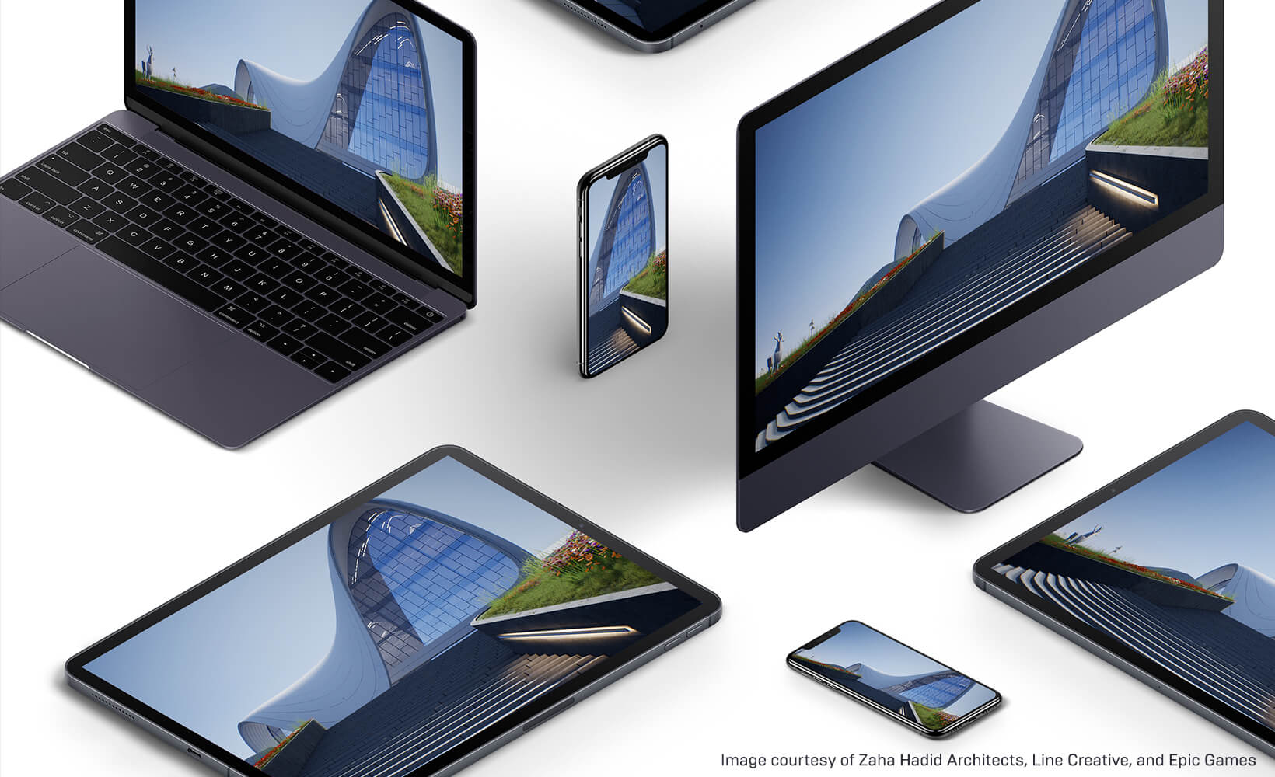

**Figure 1-1** Shared content across various platforms. Image adapted from Unreal Engine Official Website [2].

A common approach is to determine the lowest demand of entry and acceptable quality for the target user, and then develop the specified platform based on that. For example, with common or current solutions based on WebGL or HTML5, the integrity and interactivity of the displayed content, to a considerable extent, depends on the consumer’s device, especially its hardware, display mechanism, and operating system [2]. This means that to make the content available for the most users, either the shared application is developed based on the lowest acceptable device, or multiple versions of the application must be developed to meet the needs of different user groups. In such a situation, the device responsible for displaying real-time content for the end user needs to download the pertinent data and logic, and render the results to the screen. This will not only limit the quality of the experience for all end users, but sometimes need to sacrifice the image quality for the sake of smaller file sizes and faster downloads as well.

The Unreal Engine team at Epic Games set out to break the usual distribution barrier when streaming high-quality content, and have developed Pixel Streaming. Pixel Streaming allows to distribute interactive real-time content, simultaneously, to any device with the highest possible quality, and keep the experience at the host’s end [3].

Pixel Streaming works as an out-of-the-box solution via a plugin for Unreal Engine 4 (UE4) [3]. This is accomplished by separating the shared application itself, with the sophisticated hardware running it and streaming the video and audio to the user’s display device. With the help of Pixel Streaming, a three-dimensional application, created and packaged with UE4 Integrated Development Environment (IDE), is capable of running remotely on a desktop PC or a server in the cloud, and using only a small stack of additional web services to share favorable experiences without considering the end client or platform.

In this context, it is worth demonstrating this technology by using a 3D interactive application as an example and investigating how well it distributes real-time content for various devices and gives people a better experience. The growing visual quality and flexibility of real-time contents seem to have created changes in the industry. Hence, a research and discussion on the advanced technology can be conducted.

Pixel Streaming addresses all the user and technical considerations for distributing content in the Age of Experience, where the focus is on deployment of the best content at the highest fidelity available. Pixel Streaming can share highend experiences without consideration of the end client or platform, and will work within larger platform setups that have various channels for both offline or online content.

**1.2 Goal**

Against this background, the main goal of the thesis is to explore the advanced technology and demonstrate the acquired level of learning by developing a car configurator application that can runs as a streaming application from a test server. Users will be able to connect to the test server using any modern web browser that supports HTML5 and functionally interact with the 3D application.

The Unreal Engine will be used as the main tool in the project context and as a game engine to create the car configurator application. The application as well as the streaming technology will be finally evaluated in terms of usability and performance.

**1.3 Thesis Structure**

The thesis is structured in six general chapters. After the introduction was given in Chapter 1, Chapter 2 gives at first a general idea of web rendering strategies and WebRTC, an open framework for the web to make Real-Time Communications (RTC) available in the browser [4], and covers the basics of Unreal Engine 4 that will be used in the example project. The theoretical basement of Pixel Streaming is illustrated in Chapter 3. Subsequently, Chapter 4 describes the implementation details of building the car configurator application and applying Pixel Streaming. Chapter 5 then discusses the results with respect to the research questions based on a brief user survey and the performance of the application. Finally, the conclusion sums up the project findings and foreseen evolution of this technology is given at the end of the thesis in Chapter 6.

**1.4 Development Method**

In order to stay flexible during the development, the whole thesis project is managed based on Scrum, an agile project management methodology or framework. It helps advance the project and deliver new application capability about every 2 weeks.

The task planning is managed with a digital Kanban board tool GitKraken Glo which is used for task and issue tracking. The whole management and progress of the project will be reflected on the Kanban board and the project-related materials are managed with GitHub, a Git repository hosting service, and GitKraken, a Git GUI client.

All the tools used in the project’s context are listed and described below in section 1.6. The project is developed in Unreal Engine 4 based on blueprints. It is the visual scripting system inside UE4 and is a fast way to start prototyping the target application. Creating 3D models will not be part of the author’s work in the thesis context. Therefore, most materials are found on the Internet and modified in Blender. They will be referenced in the appendix (see Appendix D). Some design scribbles and digital icons are produced with Photoshop.

**1.5 Development Workflow**

At the beginning of the thesis, the focus obviously lies on research and study the existing approaches and required software that relate to the projects. After this stage, the development of the car configurator application is the next major part. This stage is the iteration for the visual design, and continues as long as a significant progress is made. After completing the application, the Pixel Streaming is applied and tested. The project needs to fit into the described development methods (see section 1.4).

**1.6 Tools**

This section covers the tools that are used during the project. Unreal Engine 4, Blender, and Photoshop are utilized during the development of the car configurator application. The remaining software is used for project planning and management.

**Unreal Engine 4**

The Unreal Engine is a game engine developed by Epic Games. The latest release is Unreal Engine 4, which launched in 2014. Most of the functional and interactive prototyping will be done with the UE4, based on Blueprint Developer and Unreal Motion Graphics (UMG) in particular for graphical user interface (GUI) implementations. The engine also provides fast and accessible options for packaging and exporting a project with much ease. More essential content about UE4 will be introduced in section 2.3 in detail.

**Blender**

Blender is a free and open source 3D computer graphics software toolset that supports the entirety of the 3D pipeline, such as modeling, rigging, animation and so on [5]. In order to perfect the imported car model, this software is only used to modify some model settings before importing into the UE4. Since only the simple setting of the model is required, Blender is suitable for beginners. The author has only learned the basic operations in Blender.

**Adobe Photoshop**

The Adobe Photoshop is an excellent imaging and graphic design software. It is widely used by photographers for photo editing and by graphic designers and Web designers to create and change images for web pages. The author has expert knowledge of this software and has used it to make some icons or figures used.

**Git & GitHub**

Git is a type of version control system (VCS). Git stores a project or a set of files in a data structure called a repository and helps you track changes to files. It is distributed, where users install locally to manage source code. GitHub is a Git repository hosting service and provides a Web-based graphical interface [6]. GitHub is an online service to which developers who use Git can connect and upload or download resources. The complete UE4 source-code is available on GitHub (see).

**GitKraken & GitKraken Glo**

GitKraken is a Git GUI client which make developers more productive and efficient with Git. GitKraken Glo is a digital Kanban board that is fully integrated with GitKraken. It is used for task planning during the development, supporting different categories for tasks, assigning people and dates, labelling tasks, and plenty of useful functions for project management.

**Jitsi Meet**

Jitsi Meet is a free video conferencing for web and mobile. It is used to have a video conference on a webpage without installing any software. The author uses this to have the video conference with the supervisor.

**Chapter 2**

**Fundamentals**

In this chapter an overview on web rendering and common rendering strategies is first given. The second section then describes the main concept of WebRTC. Finally, the basic essential content of Unreal Engine 4 is covered. Only Information relevant for this thesis will be covered.

**2.1 Rendering on the Web**

When talking about building a website, this can include building out the component model, handling routes and transitions, managing data and state, and even rendering and loading the assets (Figure 2-1). This section will mainly focus on the rendering part.

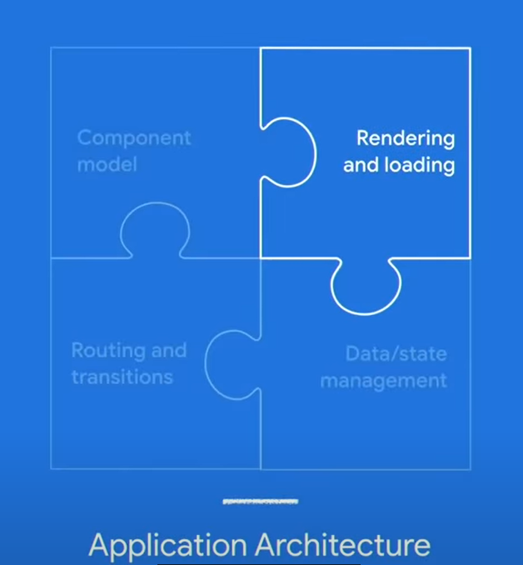

**Figure 2-1** Application Architecture. Image adapted from Google’s Reference for Web Fundamentals [7].

Web rendering is a process of generating HTML output that is ready to be rendered by web browser and viewable by users [8]. Generally, a browser will request HTML, CSS, JavaScript, and image content from a server and illustrate the page to users according to certain web standards and specifications. While initializing a web page, the browser parses the data from the server in multiple formats and create a visual effect. This process can happen anywhere and anytime depending on the rendering strategy [8].

**2.1.1 Modern Web Rendering Strategies**

There are several strategies to choose where and when for rendering. Here is a brief introduction to four common rendering strategies. They are Static Rendering, Prerendering, Client-Side Rendering (CSR), Server-Side Rendering (SSR), and Universal Rendering [8].

**Static Rendering** means utilizing a content delivery network (CDN) to host the recently produced static page content and generating the page ahead of time

**Prerendering** enables to preload all the elements on the expected page ahead of time so that visitors can see the next page faster.

**Client-Side Rendering (CSR)** means that the browser downloads the entire page and renders the JavaScript to fill the contents. All the processes including data and logic fetching, templating and routing are managed on the client side.

**Server-Side Rendering (SSR)** allows interpreting the page content on the server side, which avoids additional round-trips for fetching data, creating the page, and sending it back to the client.

**Universal Rendering** is a combination of CSR and SSR. Large parts of the data and logic can run on the server and on the browser, attempting to reach the balance between both CSR and SSR.

In the following part, CSR and SSR will be described in detail and compared.

**2.1.2 Client-Side Rendering (CSR)**

The normal steps of Client-Side Rendering are listed below (Figure 2-2):

* The user visits the web page in the browser, sending a request to the website.
* The browser receives and downloads the supporting files (HTML, CSS, JavaScript, etc.) from the server or CDN.
* The browser executes JavaScript codes to fetch dynamic content from the API server.
* The final content is **rendered and interactable** through DOM processing in the web browser.

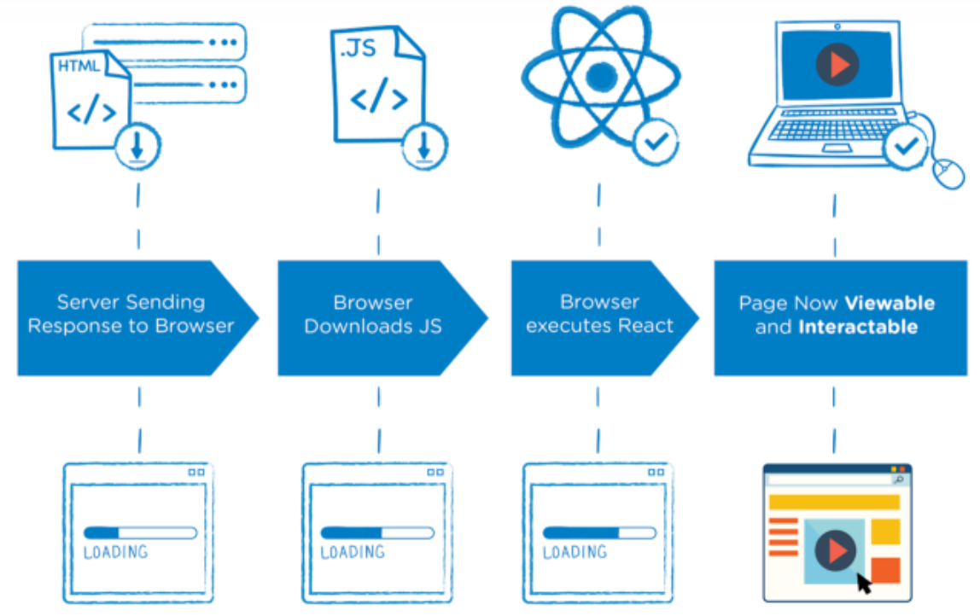

**Figure 2-2** Process of Client-Side Rendering. Image adapted from [9]

The main tasks are done on the client’s browser, so it is called Client-Side Rendering. With CSR, only the data is transferred back and forth and most resources are loaded once during the whole lifespan.

**2.1.3 Server-Side Rendering (SSR)**

Server-Side Rendering generally follows the steps below (Figure 2-3):

* The browser sends a request to the website and the server creates the “Ready to Render” [10] HTML files.
* The web page content can be quickly **rendered** by the browser but it’s not interactive.
* The browser downloads and executes the JavaScript.
* Now the interactions can be executed and the page is **interactive**.

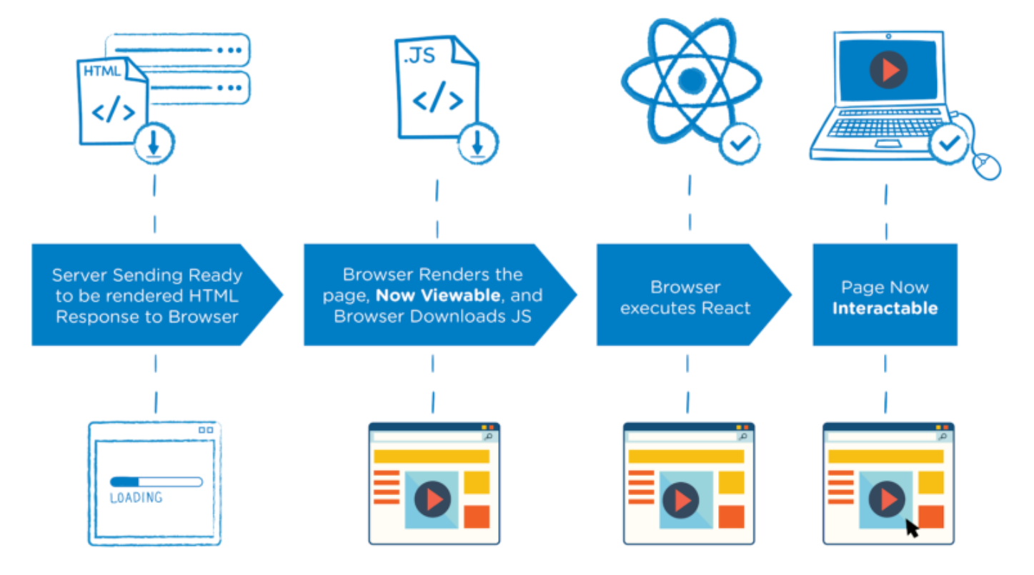

**Figure 2-3** Process of Server-Side Rendering. Image adapted from [9]

Server-Side Rendering prepares the web page content with data directly on the server. Therefore, it is commonly faster to deal with the requests in comparison to Client-Side Rendering, but it comes with a burden on the server side.

**2.1.4 Differences between CSR and SSR**

Since the two rendering strategies are different in content processing, each of them has its own benefits and drawbacks.

For Client-Side Rendering,

Benefits are:

* Fast website rendering after the initial load
* Rich site interactions
* Less server resources required

Drawbacks are:

* Unfriendly search engine optimization (SEO)
* Slower initial load
* Much burden on the browser

For Server-Side Rendering,

Benefits are:

* Better search engine optimization (SEO)
* Faster initial page load
* Great for static sites
* High performance on a wide range of devices

Drawbacks are:

* + Relatively slow overall page rendering
  + Non-rich site interactions
  + Less flexibility for deployment

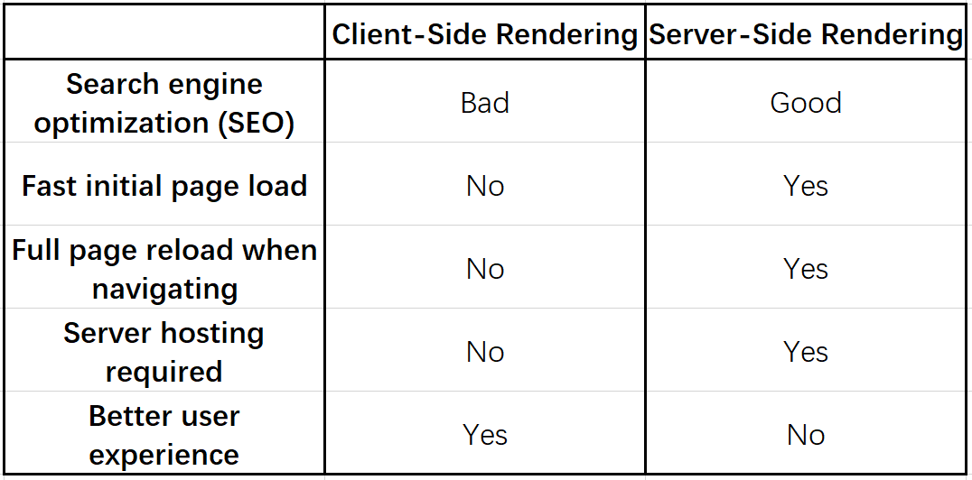

Table 2-1 Comparison between CSR and SSR. Table made from Microsoft Excel.

The above table (Table 2-1) gives a clearer comparison between CSR and SSR. The answer to which one is better cannot be given. It depends on what you want to do and what you want your page to look like.

**2.2 Basics of Unreal Engine 4**

The Unreal Engine, created by the game and software development corporation Epic Games, is one of the world leading game engines. It offers all basic functionality to create modern games or other applications and supports multiple platforms, such as Linux, Windows, macOS, iOS, Android and HTML5. Furthermore, Unreal Engine 4 provides various free project templates, sample contents, learning projects and plenty of other resources in different fields to lead an easy and quick start. Coding can be done by either the unique visual scripting language Blueprints or by C++ programming. While C++ has more access to the hidden part of the engine, Blueprints are easier to get started. This thesis’s project is done completely by the ue4 Blueprint Visual Scripting.

In the following, only a general overview will be given on the parts that are pertinent to this thesis. Considering this, the below-mentioned topics will be briefly covered:

* + Blueprints
  + Static Mesh and World Coordinates
  + Materials and Textures
  + Unreal Motion Graphics (UMG)

**2.2.1 Blueprints**

The Blueprints Visual Scripting system in Unreal Engine is a scripting system using a node-based interface to visually connect events, functions, or variables with wires, thus creating complex functionalities. [11] The two most common used types of Blueprints are Level Blueprints and Blueprint Classes.

**Level Blueprints** are global and possess level-wide functionalities meaning that they can also communicate across Class Blueprints. By default, each level is equipped with one Level Blueprint, and this can reference and manage Actors and other things within the level [12]. The Level Blueprint can interact with Blueprint Classes (see below) placed in the level.

**Class Blueprints**, on the other hand, are used locally and contain their own variables and functionalities. Most Class Blueprints inherit from several parent classes. The most important is probably the Pawn class which is the physical representation of a player or AI entity in the game world.

The main events to perform code are *Event BeginPlay* and *Event Tick*. The *Event BeginPlay* function only happens after the corresponding Blueprint starts. The *Event Tick* function is called on every frame and is very expensive regarding the performance since every piece of code will be executed on every game loop. [13]

**2.2.2 Static Mesh and World Coordinates**

Static Meshes are geometries with a set of polygons which make up a main part of the world architecture for levels created in Unreal Engine. They are basic units that can be rendered by the graphics card. The 3D models can be imported from the external modeling software through the Content Browser. In this project, most of the Static Meshes are offered by Unreal Engine. Only the car model is edited in Blender and then is imported into the Unreal Editor.

The world coordinate system of Unreal Engine 4 is a Cartesian three-dimensional coordinate system (X, Y, Z or R, G, B) where 1 Unreal Engine unit (UU) equals to 1 centimeter. [13]

**2.2.3 Materials and Textures**

In computer graphics, 3D polygons composed of triangles or squares form the worlds. The most basic and efficient polygon is the triangle and it can be drawn and colored to the screen at high speeds. The process of generating 2D projections of 3D shapes and selecting colors, lights, shadows, or reflections to the triangle is called rendering. [14]

In Unreal Engine, the Material Editor is provided to color 3D shapes. This tool produces visual elements that can be applied as paint to the surfaces of models. There are a lot of parameters can be adjusted in UE4, such as the color, shininess, roughness, opacity, etc. These different visual settings combine a material and it can be applied to a mesh to offer different visual look.

A texture is defined as a two-dimensional image that used in Materials and can be mapped onto a 3D shape. Texture coordinates present how an image is mapped to a 3D shape. The coordinate system is characterized by the UVs where U is the horizontal location and V presents the vertical location.

**2.2.4 Unreal Motion Graphics (UMG)**

To show users more information, typically 2D user interfaces (UI) are being implemented. In Unreal Engine 4, the Unreal Motion Graphics (UMG) tool is provided to create UI elements such as in-game HUDs, menus, or other interfaces. It is implemented within Widget Blueprints in which developers can design information texts or add buttons or sliders to realize different functions. [15]

**Chapter 3**

**Pixel Streaming**

This chapter dedicates to giving an overview of the streaming technology in Unreal Engine 4. Then the setups of Pixel Streaming will be covered. The chapter will additionally discuss the comparison between Pixel Streaming and other distribution solutions, such as WebGL and HTML5, and finally give the reasons for developing Pixel Streaming.

**3.1 Pixel Streaming Overview**

People generally run the Unreal Engine application on the device which runs the gameplay logic and presents the game world on the screen. Despite of the distributed parts of the gameplay logic, the task of rendering the game world will be done on each device. Even though the HTML5 version of the application is used to run in the web browser, the gameplay logic and the rendering part still needs to be done on the client side.

With Pixel Streaming, people can run the Unreal Engine application remotely across a network, using only a small stack of additional web services. Either a physical desktop in the local network or a remote virtual machine can be used to run the gameplay logic and rendering. The video and the audio of the Unreal Engine Application is encoded into a stream and then sent to a separate machine. People can connect with any modern web browser on their devices, whether desktop or mobile, and view the pre-rendered frames and audio without installing or downloading anything. Also, users can interact with the application with a variety of different input methods, which is sent back to the application. (Figure 3-1)

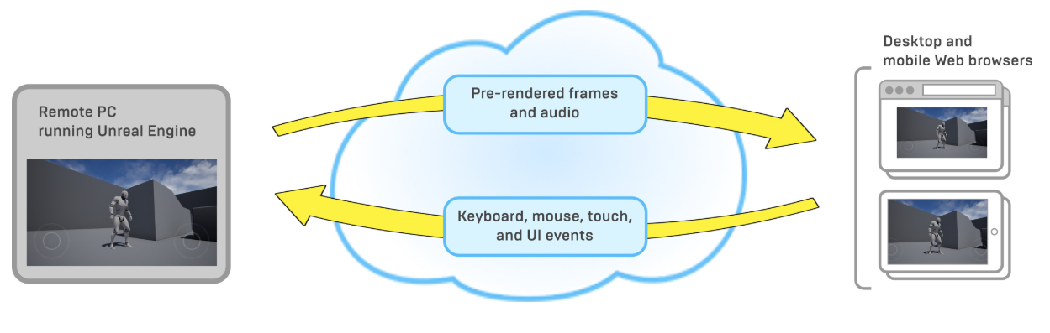

Figure 3-1

Pixel Streaming is implemented as an Unreal Engine plugin released in UE 4.21. The Pixel Streaming in UE4 is an out-of-the-box solution that provides all the required components. Once the plugin is enabled, all you need to do is to start the provided servers. It provides sort of a real-time interaction and can be customizable.

**3.1.1 Technologies**

The Pixel Streaming technology mainly uses the following technologies:

**NVIDIA NVENC**

NVIDIA NVENC in the graphics cards is used to code the video stream into H.264, a video compression standard in hardware. It can provide up to 4K, 60 FPS streams, which is a high performance.

**WebRTC**

WebRTC is short for Web Realtime Communications, which is a powerful and advance technology and standard. It can be added to some applications to obtain the peer-to-peer real-time communication capabilities based on open standards. With WebRTC, people can share video, audio, and data in the web browser, without plugins.

WebRTC is used to do the distribution in the Pixel Streaming system. It actually is used right now in many places, from basic web applications using cameras or microphones to advanced video sharing applications, like the video chat apps using today. WebRTC allows to decode the H.264 video on the hardware, so as a result, a high hardware specification is not required. All the primary browser can support it natively nowadays. Additionally, WebRTC can automatically adapt to poor network conditions. It will track and update the video if the user has a bad connection.

**Standard web technologies**

In terms of the web stack, a standard Node.js server and a JavaScript implementation are used in the Pixel Streaming system.

**3.1.2 Components**

**Pixel Streaming Plugin**

The Pixel Streaming Plugin is integrated directly inside the Unreal Engine 4 where NVIDIA NVENC is integrated. It uses H.264 video compression to encode the video stream and sends the stream to the WebRTC proxy.

**WebRTC Proxy**

The web browsers connect to WebRTC Proxy rather than the Unreal Engine application. It uses WebRTC to distribute the video and audio streams to web browsers.

**Signaling Web Server**

The role of the Signaling Web Server is to coordinate the connections from the clients to WebRTC Proxy and host the HTML page that the user goes to.

**STUN Server & TURN Server**

WebRTC may require two extra servers if connecting over the open network: STUN and TURN. The STUN server is used to get the public IP address and the TURN server is used for networks that don’t support the WebRTC protocol. Both servers are for NAT (Network Address Translation) issues.

**Browser Code**

The browser code is the JavaScript API that has been included in the Pixel Streaming system.

**3.1.3 Connections**

Figure 3-2 presents the architecture of the Pixel Streaming system and the connection between components. On the left is the Pixel Streaming Plugin which connects to the WebRTC Proxy. Then it connects to the Signaling Web Server that handles the connection of clients. A direct connection to the web browsers at last is established. The Signaling Web Server is responsible for controlling and managing the connections after the initial communication is done. The STUN Server and TURN Server are optional.

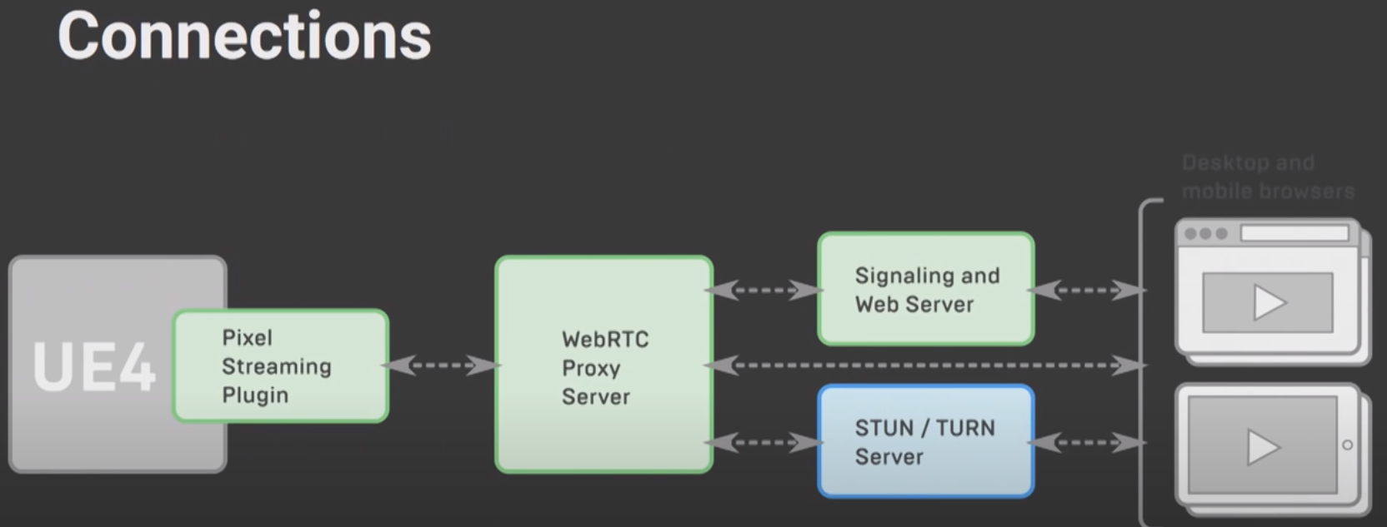

Figure 3-2 Architecture of the Pixel Streaming system

The Unreal Engine application and the browser need to send their own IP address with each other so that the Signaling Web Server can manage the connection between them. If running in a local area network (LAN), each party is able to access the other party using the private IP address locally in their own network. Otherwise, the STUN and TURN Server are required to connect between the WebRTC Proxy and browsers.

Over the open network, the STUN Server is used to figure out the public IP address of each party and send it to the other party. Then the Signaling Web Server can continue to handle the connections between them. Alternatively, the TURN Server can be used to relay the media stream. It can connect to both the Unreal Engine application and the browser. Then the media stream is sent from the application to the TURN Server and it forwards the stream to the browser. The Unreal Engine application has an indirect connection with the browser.

The STUN and TURN are a set of protocols for NAT traversal while building the peer-to-peer communication. Together with the ability to fall back from one server to another, they constitute the ICE (Interactive Connectivity Establishment) framework.

**3.2 Setups for Pixel Streaming**

This section gives three common use case setups for Pixel Streaming.

**Connection within a LAN**

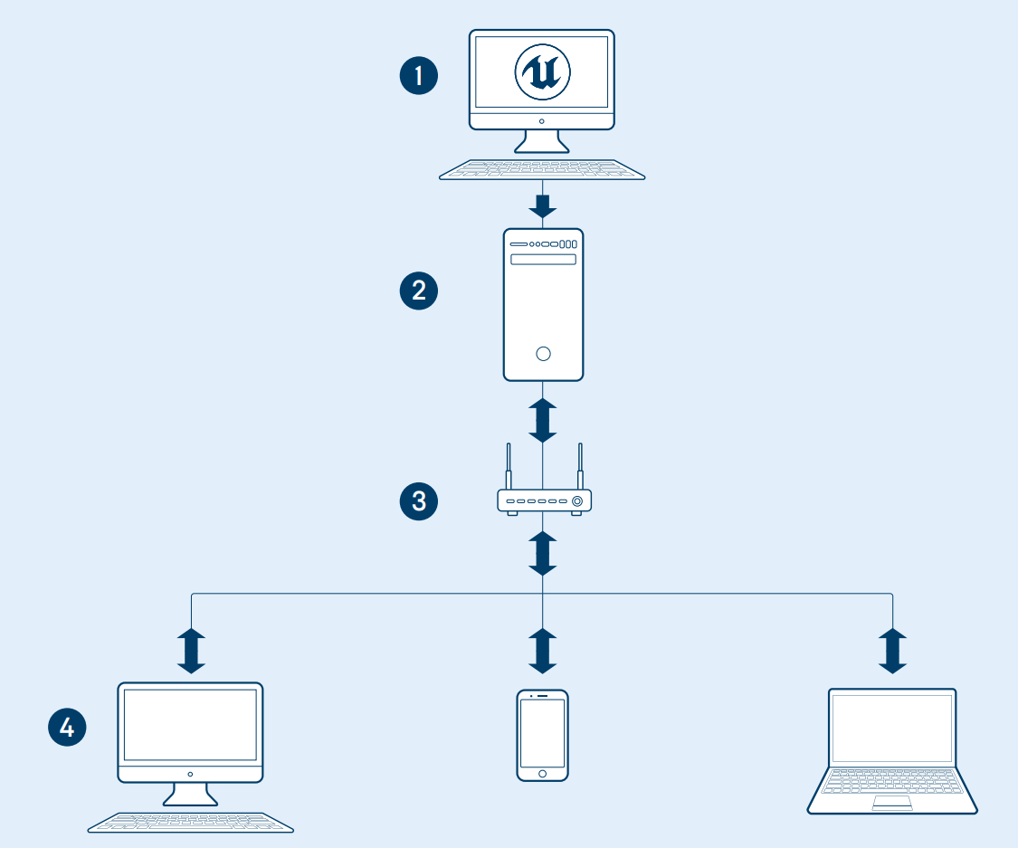

Figure

**Presentation**

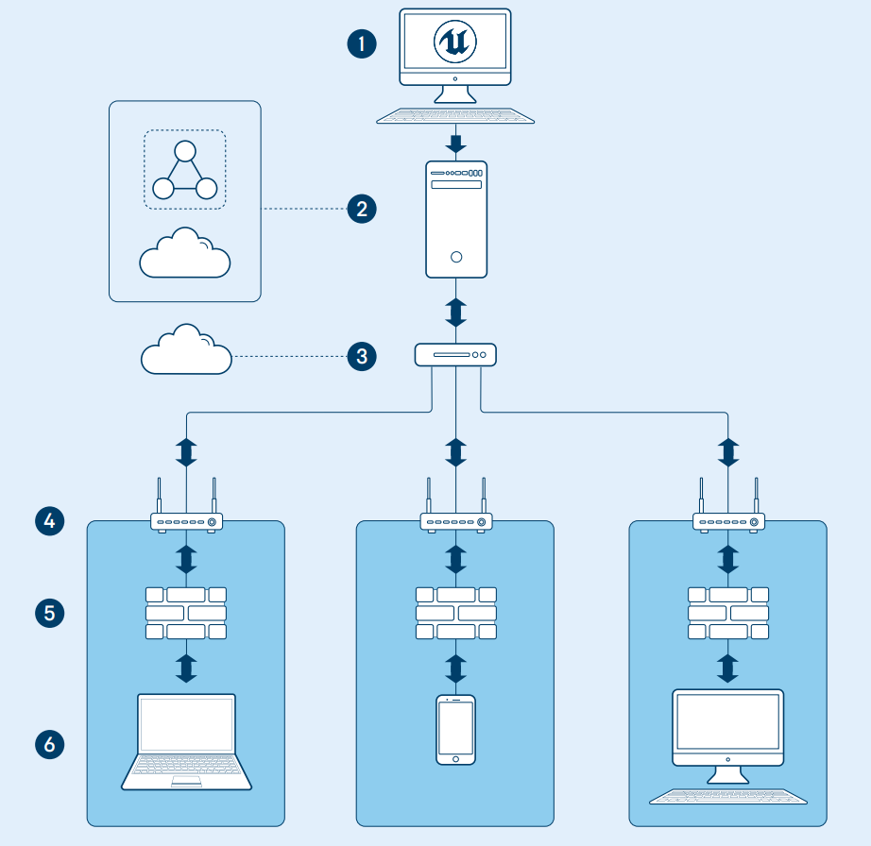

Figure

**Unique experience for everyone**

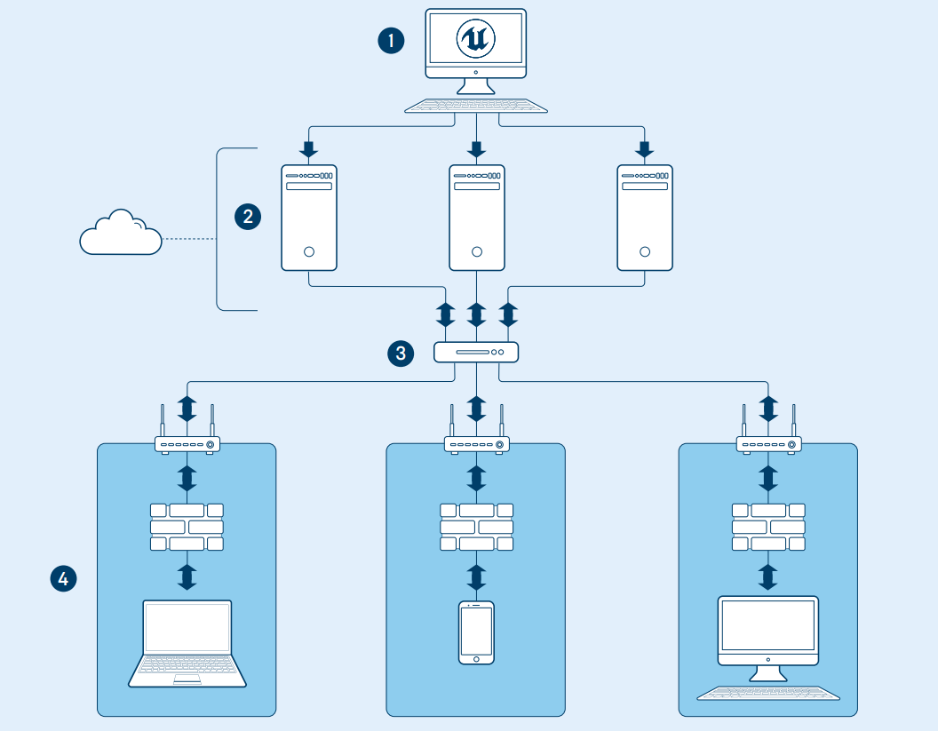

Figure

**3.3 Benefits and Limitations**

Pixel Streaming provides several possible benefits:

* **Lightweight client.** Everything is done on the server side, so just a modern web browser is enough to use this technology.
* **No installation required.** There is no need for any prerequisite installations. The only thing is to download the media stream when running the application.
* **Multiple platforms supported.** The Pixel Streaming system supports multiple platforms and just one package of the application is required.
* **Deterministic high quality on all platforms and devices.** Running Unreal Engine application on a high-end host system, whether mobile devices or lightweight web browsers can display the same high-quality graphics as on the host device.
* **Multi-user support.** Pixel Streaming can multicast the Unreal Engine application to many users so that users see the same stream at the same time.
* **Lower latency.** The WebRTC peer-to-peer communication framework is used to offer the lowest achievable latency between the user and the application.
* **Easy to set up.** Only a small number of components make up the Pixel Streaming system so that everyone can use it easily.
* **Security.** Users only have the video and audio stream, so they can’t access the private IP of the client. Therefore, Pixel Streaming has the same security as the web pages. All the data is stored on the server side and only the streams are distributed to the client side.

Limitations…..

**Chapter 4**

**Sample Development Process of Car Configurator Application on Pixel Streaming**

This chapter covers the sample development process of a car configurator application using Unreal Engine 4 version 4.24.3. All the functions were implemented by Blueprints Visual Scripting. The Pixel Streaming technology in Chapter 3 will be applied to this application and tested on some devices. At first the basic architecture of this application is determined. Then the environment and the car model are selected and designed to provide both a realistic and immersive atmosphere. In order to manipulate within the world, UMG is developed to provide a functional UI view. In the end, this application will be used as an example to do Pixel Streaming. An overview of the workflow is given in Figure 4-1.

Workflow Image

**Figure 4-1** Overview of the workflow for the project. Image created in Photoshop.

**4.1 Basic Architecture**

In order to make the entire development process organized and clearer, the basic architecture must be determined first. The wireframe is first done according to the overall design of the application and detailed functions are then listed. At last, the project is set up in Unreal Engine 4 including the Game Control setup.

All the assets are from the Unreal Engine Official, the detailed source of all assets is presented in the Appendix E.

**4.1.1 Overall Design**

The goal is to design a real time interactive car configurator application that users and customers thus can configure cars. The car configurator allows users to design and build their own cars. To ensure that the car specifically caters to the users’ interest, they can choose the car paints, wheel rim colors, add LUT filters and so on. With the power of Blueprints and UMG tools, the following interactions will be created.

* **Easy User Interface** The user interface should be clear for users to manipulate in the car configurator application.
* **Car Paint Selector** This allows users to change the car paint from the preset options.
* **Rim Color Selector** This allows users to change the wheel rim color of the car from the preset options.
* **LUT Setting** Users can adjust the atmosphere style of the application by choosing the LUT.
* **Turntable On/Off** Users can turn on or turn off the rotation of the turntable.
* **Background Music On/Off** Users can turn on or turn off the background music.
* **Screenshot** This enables users to have a screenshot and the screenshot is saved in the project folder.
* **Exit Application** Users can exit the application from the UI button.

Based on these features, the wireframe of this application was created by the Photoshop (Figure 4-2). The submenu will only appear when the user clicks certain button in the main menu bar.

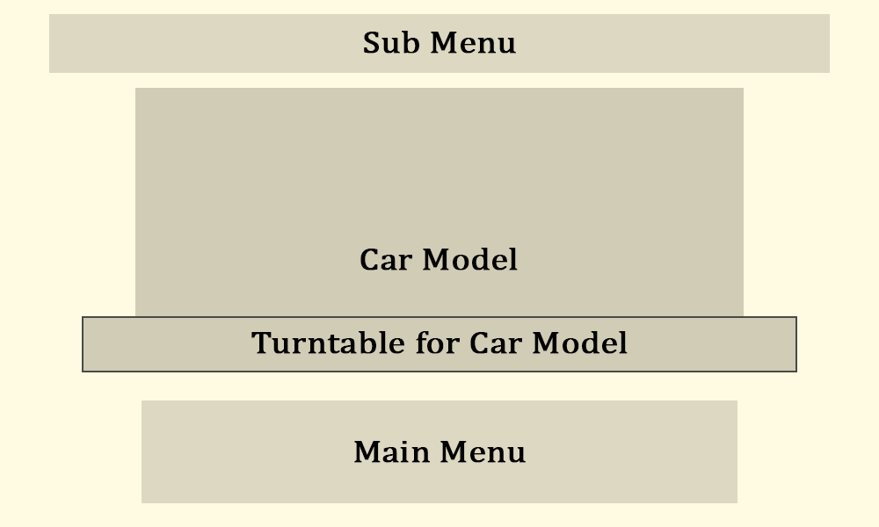

**Figure 4-2** Wireframe of the Car Configurator Application. Image created by Photoshop.

The whole source code of this project is available in GitHub and attached DVD (see more information in Appendix E).

**4.1.2 Project Setup**

After having determined the overall direction, the car configurator project now can be created in Unreal Engine. This project was called ***CarConfigurator_Hou*** and a default level map named ***CarConfigurator*** was also created through the UE4 menu. A project can include multiple levels, but in this project, there is only one level.

Every project needs input from the user and a car configurator is no different. For the default level map, the controls are set up to be the first-person game mode in which players can move around the camera by using the mouse click and the W, A, S, D keys. This will be practicable in most circumstances, but for a car configurator, users should be provided a still camera and visible mouse cursor to operate in the car configurator application. The game controls should be set up so that the mouse doesn’t act as normal does which is to be in first person viewport. This can be realized through the *PlayerController* and *GameMode* Blueprints.

**PlayerController**

The *PlayerController* is the interface between the *Pawn* and the human player controlling it. It implements functionality for taking the input data from the player and translating that into actions, such as movement, using items, firing weapons, etc. In this car configurator application, a *PlayerController* Blueprint named ***PC_Configurator*** was created. The following options were clicked to make the mouse cursor visible and some mouse events available (Figure 4-2).

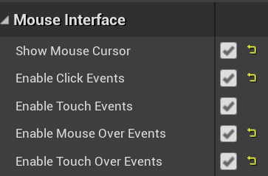

**Figure 4-2 *PC_Configurator***Blueprint: settings in the blueprint.

Screenshot from the UE4 project.

**GameMode**

The *GameMode* Blueprint defines the game’s set of rules. The rules can include how players join the game, game pausing, and level transition, as well as any game-specific behavior. The *GameMode* is set for each level, and it can be reused in multiple levels. In this application, a *GameMode* Blueprint named ***GM_Configurator*** was created. The setting of *Player Controller Class* was set to the ***PC_Configurator*** created before so that users can operate with the mouse cursor (Figure 4-3).



**Figure 4-3** ***GM_Configurator*** Blueprint: setting in the blueprint.

Screenshot from the UE4 project.

Finally, in the *Game Mode* option applied the ***GM_Configurator*** though the World Setting panel so that the basic setup of this application was done.

**4.2 Creating the World**

This section covers the whole construction process of the world, including the environment, lighting, as well as the importing of the car model.

**4.2.1 Environment**

Two different styles of environment were provided in the separate level, ***CarConfigurator*** Level and ***CarConfigurator_Sky*** Level. Apart from the environment setting, everything else in these two levels is the same. In this application, the ***CarConfigurator*** Level is mainly used to create the remaining part. The construction steps of both environments are demonstrated below.

**CarConfigurator Level**

The first level named ***CarConfigurator*** provided users with a more abstract view. A background environment sphere was put in the world (Figure 4-4), thus creating a gray background seeing from the inside (Figure 4-5). The gradient and the brightness of the background sphere can be adjusted through two parameters ***Exponent*** and ***Intensity*** in its attached material. In this project, the Exponent value was 2 and the Intensity value was 200.



**Figure 4-4** Outside look of the background environment sphere.

Screenshot from the UE4 project.



**Figure 4-5** Outside look of the background environment sphere.

Screenshot from the UE4 project.

***Exponent*** parameter controls the gradient of this background. The larger the number, the more the dark parts in the background. Table 4-1 shows the different effect at different ***Exponent*** values with the fixed ***Intensity*** value.

Table

**Table 4-1** Effect of different ***Exponent*** values on the environment sphere.

Table created by screenshots and Microsoft Excel.

***Intensity*** parameter controls the luminous degree of this background. The larger the value, the brighter the background. Table 4-2 shows the different effect at different ***Intensity*** value with the fixed ***Exponent*** value 2.

Table

**Table 4-2** Effect of different ***Intensity*** values on the environment sphere.

Table created by screenshots and Microsoft Excel.

This environment sphere is the main part of the environment. Other parts are listed below (Figure 4-6). All these components interact with each other to provide a gray and abstract scene.

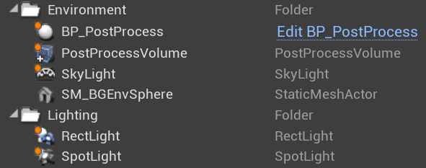

**Figure 4-6** Environment components in the ***CarConfigurator*** Level.

Screenshot from the UE4 project.

**CarConfigurator_Sky Level**

This environment settings provided by the default level simulates the real sky (Figure 4-7). They are made up of the following parts (Figure 4-8). All of these interact with each other to provide a realistic sky scene.



**Figure 4-7** Environment in the Car_Configurator_Sky Level.

Screenshot from the UE4 project.

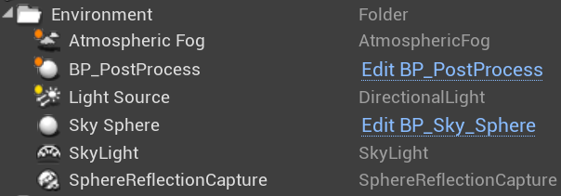

**Figure 4-8** Environment Components in the CarConfigurator_Sky Level.

Screenshot from the UE4 project.

**4.2.2 Car Model & Turntable**

**Model Pre-processing**

Model creation is not the author ’s main task, so all models are readily available. The car model used in this application was Audi_R8 which was download from the TurboSquid [16] website. Before importing into UE4, there are two things that need to be set in the Blender. The first thing is to normalize the name of each part of the car model. The naming of the various parts was messy at first. In order to distinguish more clearly when distributing materials, the components need to be renamed according to the UE4 standard. The next step is the allocation and naming of materials. In Blender, whether the material allocation is wrong needs to be carefully checked and each material also needs to have a proper name. The useless materials should be deleted so as not to cause redundancy after importing into UE4.

After ensuring that the model has no major problems, the car model was exported in FBX format. When importing into the UE4, the *Combine Meshes* option was clicked (Figure 4-9) so that the imported model was a complete static mesh instead of several scattered static meshes.

UE4 has its own naming convention. The name of the static mesh is the same as the blender file name with prefix “SM” (Figure 4-10). “SM” stands for static mesh. Also, the imported materials along with the model is the same as the component name in Blender with prefix “M” (Figure 4-11). “M” stands for material.



**Figure 4-9** Option when importing the car model. Screenshot from the UE4 project.

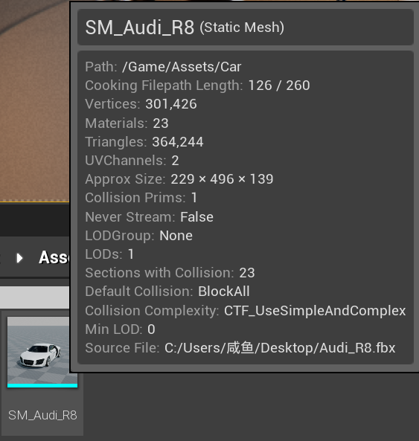

**Figure 4-10** Name of the importing model in UE4. Screenshot from the UE4 project.

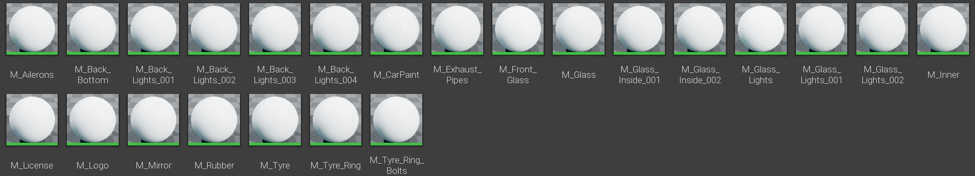

**Figure 4-11** Name of the importing materials in UE4. Screenshot from the UE4 project.

**Applying Materials to Car Model**

It can be seen from the Figure 4-11 that all the materials that have been set in Blender will be lost and become blank after importing into the Unreal Engine. Here the author will not set up these materials one by one. All the materials applied on the car model come from the automotive material package provided by UE4. It is a collection of 164 high quality automotive-themed materials and textures which have been setup for use in Unreal Engine 4 (Figure 4-12). These materials have been optimized to take advantage of techniques and features such as triplane projection and ray tracing.



**Figure 4-12** Automotive material package provided by Unreal Official.

Image adapted from the Unreal Official.

**Blueprint for Turntable**

The blueprint for the turntable is called ***BP_TurnTableSet***, which complies with the UE4 naming convention. It is based on the turntable blueprint from *Photo Studio* template that enables you to create product presentation and cinematics in a photographic studio environment. The attached materials and textures used are also from this template.

The turntable consists of three parts (Figure 4-13). The purple part is the center plate that can rotate. The yellow part is the outer plate and four ramps make up the blue edge part.

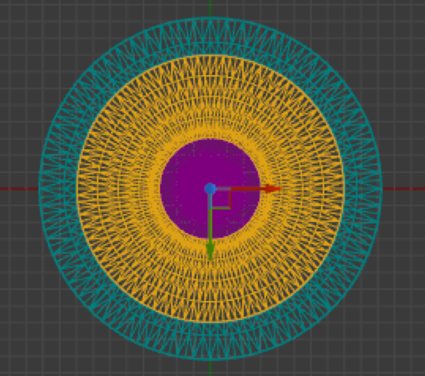

**Figure 4-13** Wireframe of the turntable seen from the top.

Screenshot from the UE4 project

The setup of this blueprint is done step by step in the *Construction Script* function which executes when instances of a Blueprint are created to perform initialization actions. The construction includes the following steps.

**1.** Select the outer plate mesh (Figure 4-14). There are five types of outer plate to choose from. They are stored in an *Enum* variable called ***FloorTypeMap*** (Figure 4-15). The selected floor type is stored in a variable called ***FloorType***. In this application the floor type is the fifth “flat floor”.

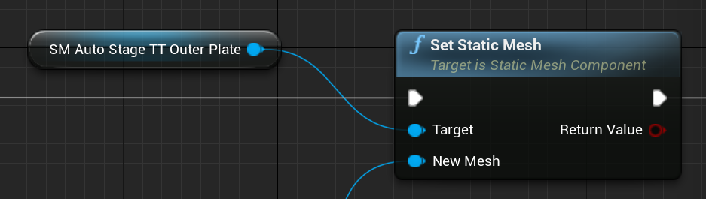

**Figure 4-14** *Construction Script* function: select the outer plate mesh.

Screenshot from the UE4 project.

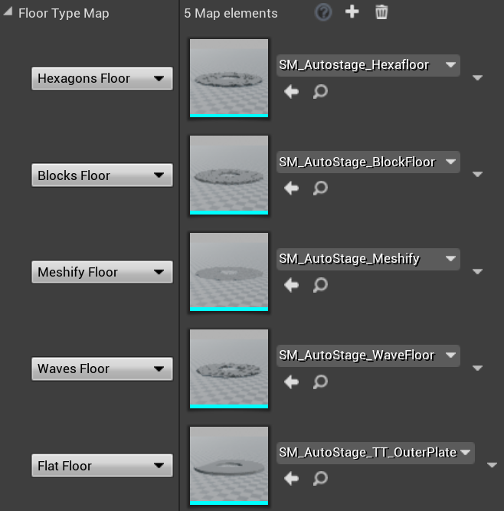

**Figure 4-15** *Construction Script* function: five types of outer plate.

Screenshot from the UE4 project.

**2.** Set the stage materials (Figure 4-16). It is a custom function called ***SetSatgeMaterials*** which is used to set all the materials of the components. All parts are attached with black matte material and the final view of the turntable can be seen in Figure 4-17.

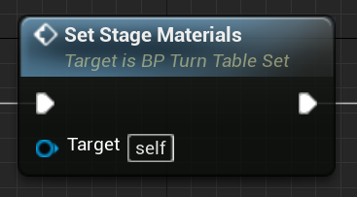

**Figure 4-16** *Construction Script* function: five types of outer plate.

Screenshot from the UE4 project.

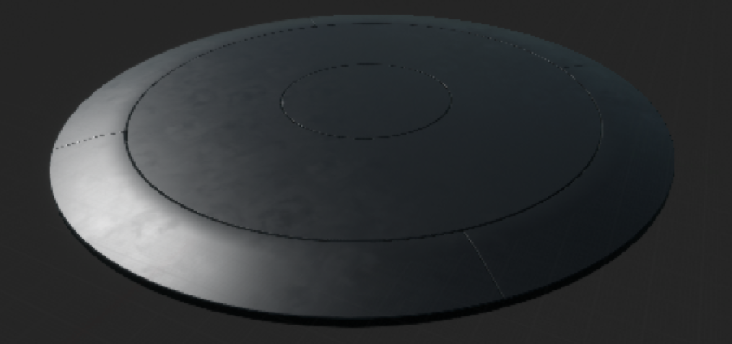

**Figure 4-17** Look of the turntable. Screenshot from the UE4 project.

**3.** Set the rotation (Figure 4-18). This function allows the center plate to rotate around the Z axis. The rotation speed will be set later in the *Event Graph*.

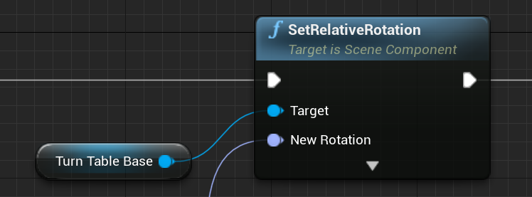

**Figure 4-18** *Construction Script* function: set the rotation.

Screenshot from the UE4 project.

**4.** Attach the car actor to turntable (Figure 4-19). The ***AttachCarActor*** function is to attach the car to the center plate so that the car can rotate with the center plate together. There are two main points in this function. The car actor should be movable and be set as a child to the center plate component.

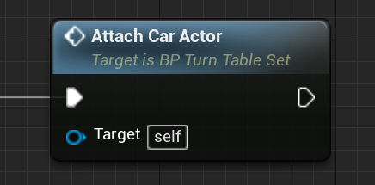

**Figure 4-19** *Construction Script* function: attach the car actor to turntable.

Screenshot from the UE4 project.

**5.** Use *Event Tick* to make rotation. *Event Tick* is a simple event that is called on every frame of gameplay. The rotation rate is stored in the ***RotationRate*** variable and is set to 10 (Figure 4-20). This value is multiplied with the output of the event ***Delta Seconds*** so that the turn rotates 10 degrees per second.



**Figure 4-20** ***RotationRate*** value. Screenshot from the UE4 project.

After these settings, the car model can now rotate with the turntable center plate when running the application.

**4.3 UMG / UI Design**

This section focuses on the development process of the UI design. The interactive UI is implemented by Unreal Motion Graphics UI Designer (UMG). It is a visual UI authoring tool which can be used to create UI elements such as in-game HUDs, menus or other interface related graphics you wish to present to your users. At the core of UMG are Widgets, which are a series of pre-made functions that can be used to construct your interface (things like buttons, checkboxes, sliders, progress bars, etc.). The Widget is stored as a Widget Component within a Blueprint class, which uses two tabs for construction: *Designer* tab allows for the visual layout of the interface and basic functions while *Graph* tab provides the functionality behind the Widgets used.

This application has only one Widget Blueprint named ***UMG_Menu***. All UI design will be implemented in this class. The UMG needs to be presented when running the application. Hence, in the Level Blueprint of ***CarConfigurator***, UMG Widget Menu was created and added to the viewport (Figure 4-21)

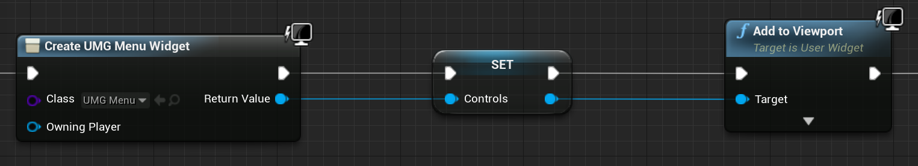

**Figure 4-21** Level Blueprint: add UMG to the viewport. Screenshot from the UE4 project.

**4.3.1 Icon Making**

Before starting to set up the layout, the icons need to be first prepared. All icons are made in Photoshop and in PNG format. Considering the functions of the main menu and the submenu in the application mentioned in Chapter 4.1.1, the following icons will be used (Figure 4-22).

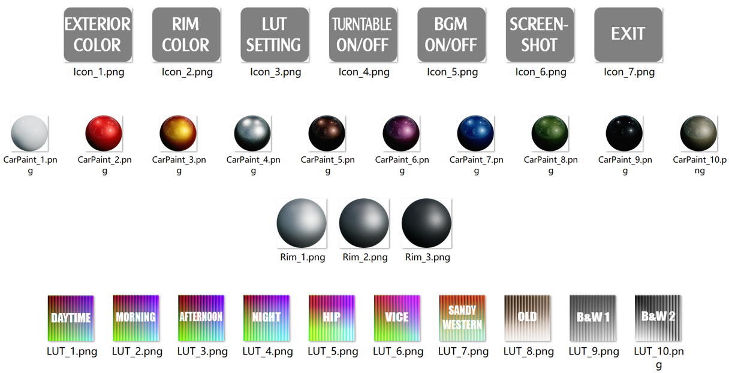

**Figure 4-22** Icons used in UI. Screenshot from the UE4 project.

**4.3.2 Layout**

The visual layout of the interface was first designed in the *Designer* tab. The basic idea is that the main menu is kept at the bottom of the application. When clicking on a certain menu option, the corresponding submenu will appear or disappear on the top. Different submenus will switch between each other with an animation.

The overall layout is shown below (Figure 4-23). This figure shows the submenu of car paint selector. Another two submenu of rim color selector and LUT setting is in the same place of this UI. Each group of icons is placed in one horizontal box.

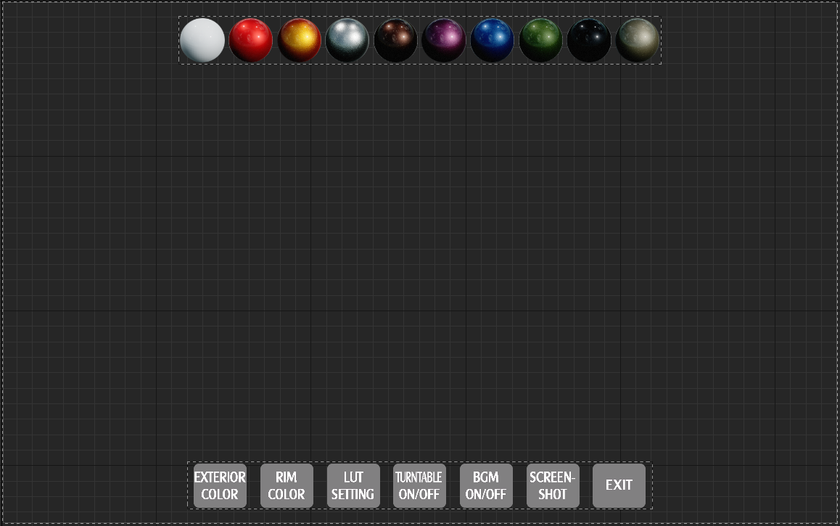

**Figure 4-23** Overall layout of UI. Screenshot from the UE4 project.

**4.3.3 Function Implementation**

Next step is to provide the functionality behind the Widgets used in the *Graph* tab. The menu contains several options to help the user find information and execute functions. It comprises the following six main options:

* + **Exterior color**: allows the user to change the car paint.
  + **Rim color**: allows the user to change the rim color of the four wheels.
  + **LUT Setting**: allows the user to change the LUT filter.
  + **Turntable ON/OFF**: controls the rotation or stop of the turntable.
  + **BGM ON/OFF**: switches the background music.
  + **Screenshot**: allows the user to do a screenshot of the scene.
  + **Exit**: exits the application.

**Exterior Color**

While clicking on the button, the submenu of the car paint selector will be appeared with animation (Figure 4-24).

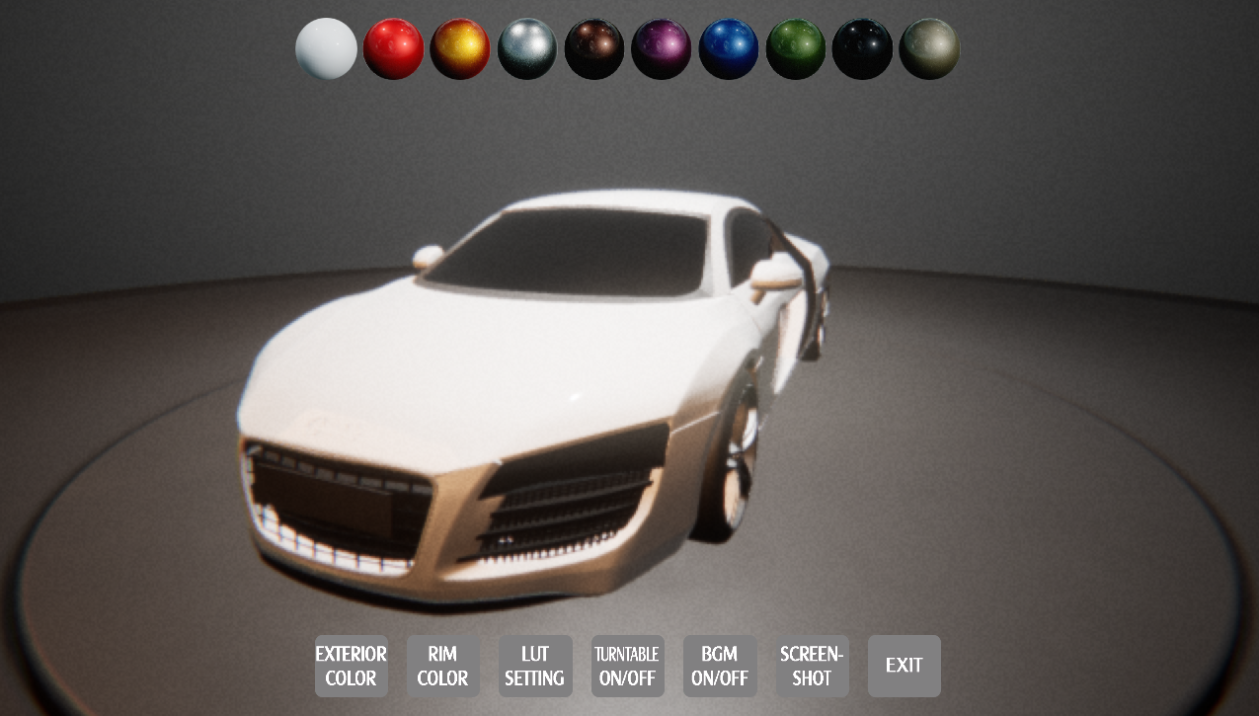

**Figure 4-24** Look when clicking ***Exterior Color***. Screenshot from the UE4 project.

To change the car paint, an *Event Dispatcher* is utilized and called every time a button is clicked on (Figure 4-25). The event, which toggles the car paint of the car, is bound within the Level Blueprint Class, because only here the visibility could be accessed.

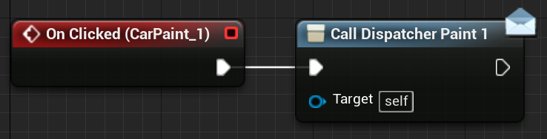

**Figure 4-25** ***UMG_Menu*** blueprint: call dispatcher when clicking the button.

Screenshot from the UE4 project.

In the Level Blueprint, the corresponding event is created and bound to the dispatcher (Figure 4-26). Once the ***ChangeToPaint_1*** event happens in this example, the car paint will change to the corresponding color (Figure 4-27). The remaining buttons are implemented in this way.

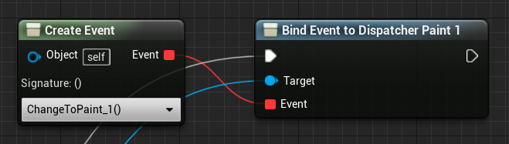

**Figure 4-26** ***UMG_Menu*** blueprint: bind event to dispatcher.

Screenshot from the UE4 project.

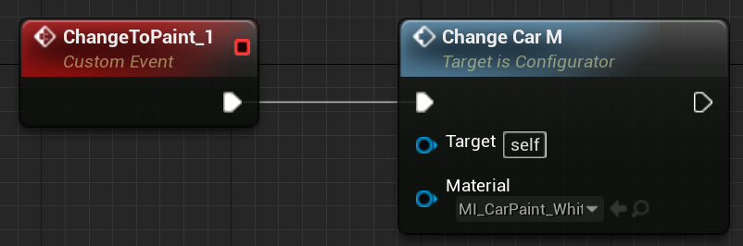

**Figure 4-27** ***UMG_Menu*** blueprint: ***ChangeToPaint_1*** event.

Screenshot from the UE4 project.

**Rim Color**

While clicking on the button, the rim color selector will be appeared with animation (Figure 4-28).

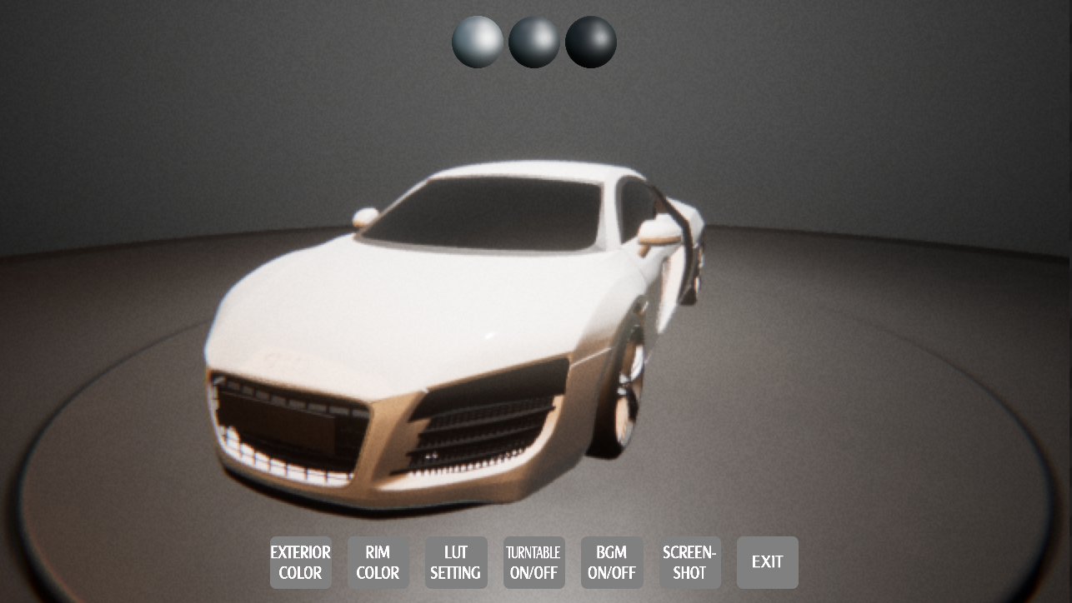

**Figure 4-28** Look when clicking ***Rim Color***. Screenshot from the UE4 project.

To change the car paint, an Event Dispatcher is also utilized and called every time a button is clicked on (Figure 4-29) like the settings in former ***Exterior Color*** buttons. The event, which toggles the rim color of the car, is bound within the Level Blueprint Class.

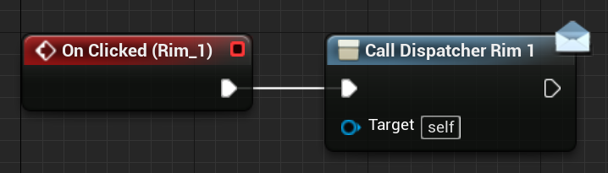

**Figure 4-29** ***UMG_Menu*** blueprint: call dispatcher when clicking the button.

Screenshot from the UE4 project.

In the Level Blueprint, the corresponding event is created and bound to the dispatcher (Figure 4-30). In this example, the ***ChangeToRim_1*** is created and used to change the rim color correspondingly (Figure 3-31).

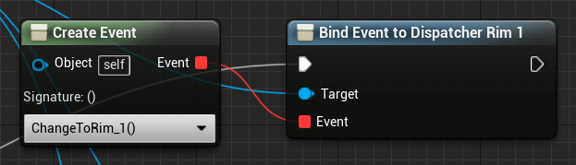

**Figure 4-30** ***UMG_Menu*** blueprint: bind event to dispatcher.

Screenshot from the UE4 project.

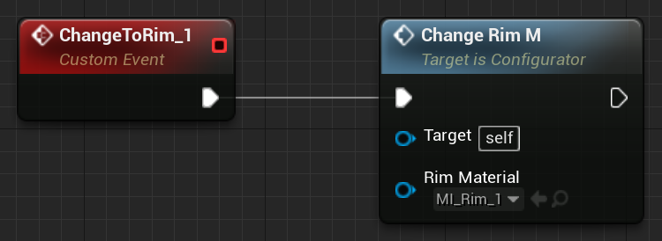

**Figure 4-31** ***UMG_Menu*** blueprint: ***ChangeToRim_1*** event.

Screenshot from the UE4 project.

**LUT Setting**

While clicking on the button, the LUT Selector will be appeared with animation (Figure 4-32).

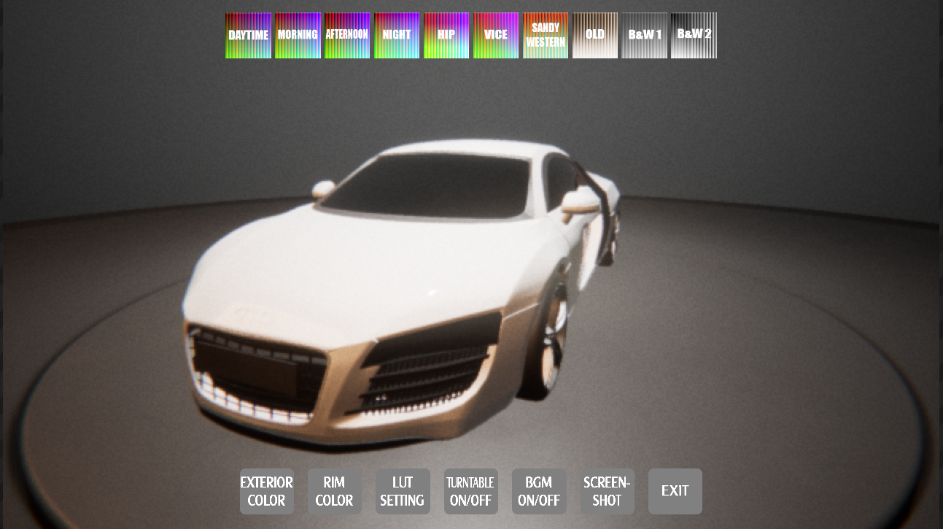

**Figure 4-32** Look when clicking ***LUT Setting***. Screenshot from the UE4 project.

介绍LUT

The implementation of these buttons is different from the previous. When one of these LUT options is clicked, it changes the *Color Grading LUT* setting in the ***BP_PostProcess*** in the world. Hence, in order to communicate with other blueprints, the ***BP_PostProcess*** Blueprint needs to obtained and saved in one variable called ***PostProcessBP*** (Figure 4-33).

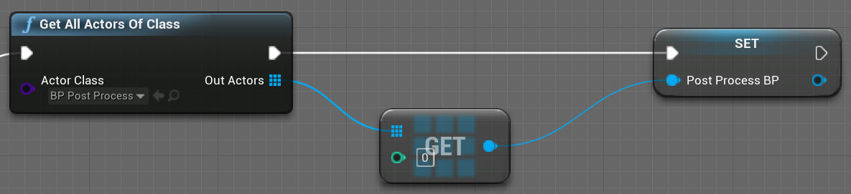

**Figure 4-33** ***UMG_Menu*** blueprint: get ***BP_PostProcess*** blueprint.

Screenshot from the UE4 project.

Once one of the LUT buttons is clicked, the function ***ChangeLUT*** in the ***BP_PostProcess*** Blueprint will be called and the corresponding parameters will also be passed into this function (Figure 4-34).

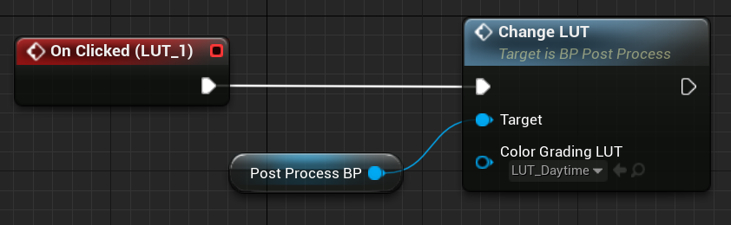

**Figure 4-34** ***UMG_Menu*** blueprint: ***ChangeLUT*** function when clicking.

Screenshot from the UE4 project.

Then in the ***BP_PostProcess*** Blueprint, the function was called and *Color Grading LUT* was set correspondingly (Figure4-35).

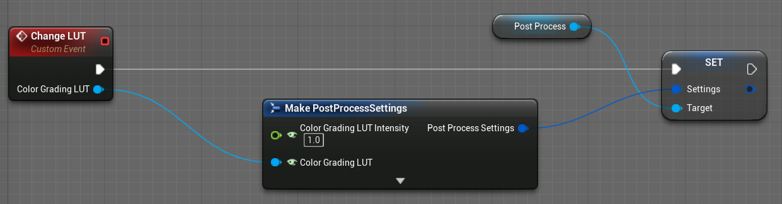

**Figure 4-35** ***BP_PostProcess*** blueprint: set *Color Grading LUT*.

Screenshot from the UE4 project.

**Turntable ON/OFF**

This menu does not include submenus. It only controls whether the turntable rotates. The rotation rate is set in the ***BP_TurnTableSet*** Blueprint, so the ***BP_TurnTableSet*** first needs to be obtained in UMG and saved (Figure 4-36).

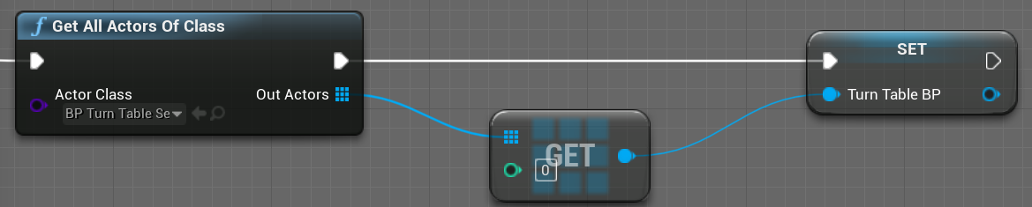

**Figure 4-36** ***UMG_Menu*** blueprint: get ***BP_TurnTableSet*** Blueprint.

Screenshot from the UE4 project.

If the turntable is rotating, the ***RotationRate*** is set to 0 when clicking the button, and vice versa. The ***RotationRate*** variable in the ***BP_TurnTableSet*** blueprint need to be public so that it can be directly accessed in the UMG Widget (Figure 4-37).

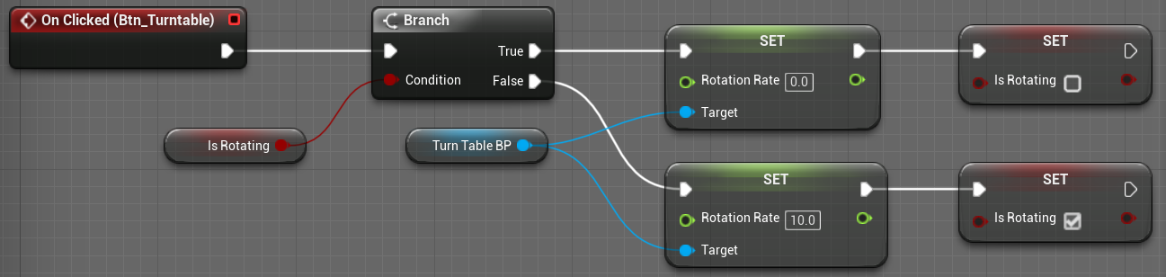

**Figure 4-37** ***UMG_Menu*** blueprint: ***RotationRate*** change when clicking the button.

Screenshot from the UE4 project.

**BGM ON/OFF**

The behavior of audio playback in the Unreal Engine is defined within Sound Cues (Figure 4-38). When the application is running, the background music is open by default. The user can click this button to turn off the background music and can also click it again to reopen the music.

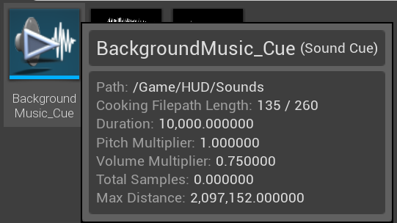

**Figure 4-38** Sound Cue of BGM. Screenshot from the UE4 project.

**Screenshot**

When a screenshot is initialized, all submenus are closed and the animation appeared. In addition to the animation and sound effects, the screenshot is mainly done by the *ExecuteConsoleCommand* function. It executes a console command called ***HighResShot 2*** [17] which takes a screenshot that is twice as big as the screen resolution (Figure 4-39).

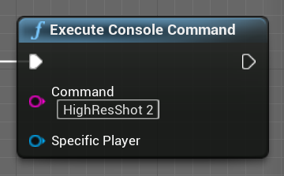

**Figure 4-39** ***UMG_Menu*** blueprint: screenshot implemented.

Screenshot from the UE4 project.

By default, any screenshots will be saved to the following location in your project folder: Saved\Screenshots\Windows. When you do take a screenshot, the following message will be displayed in the lower right-hand corner of the screen (Figure 4-40). Clicking on the message will display the folder containing your screenshots.



**Figure 4-40** Screenshot saved path. Screenshot from the UE4 project.

**Exit**

To exit the application the simple function *Quit Game* was called once the button to quit the application has been pressed (Figure 4-41).

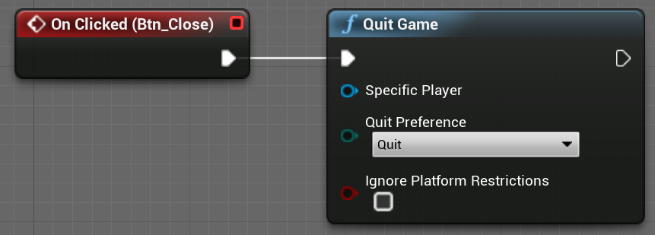

**Figure 4-41** ***UMG_Menu*** blueprint: quit game. Screenshot from the UE4 project.

**4.4 Camera Setting**

For a car configurator, the camera must be fixed and the user can only rotate left and right to view the car model. In order to realize such a function, a Pawn class named ***BP_Camera*** is created. This blueprint consists of two components: *SpringArm* and *Camera*. The camera component acts as the main camera for the application scene and the spring arm component is used to position the camera appropriately in 3D space [18]. The camera component is a child of the spring arm component, as the spring arm is used to position and rotate the camera (Figure 4-42).

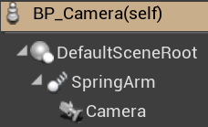

**Figure 4-42** Components of ***BP_Camera***. Screenshot from the UE4 project.

**4.5 General Overview**

This is the look of the car configurator application when playing in editor (Figure 4-43).

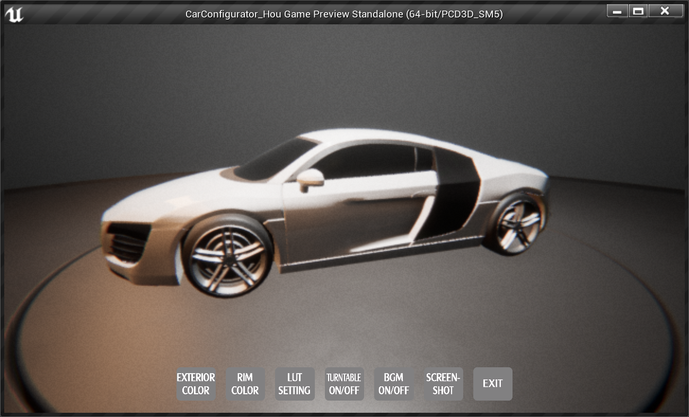

**Figure 4-43** General overview. Screenshot from the UE4 project.

**4.6 Applying Pixel Streaming**

This section will apply the Pixel Streaming technology on the previous car configurator application. Two circumstances will be provided. One is running in a LAN, the other is to run over an open network, which will use the STUN and TURN Server.

**4.6.1 Local Pixel Streaming**

The following is the steps of streaming the car configurator application in a local network.

1. **Enable the Pixel Streaming Plugin**

To use the Pixel Streaming, the first thing is to enable this plugin in Unreal Engine 4 (Figure). Then the Unreal Editor will restart again for the plugin changes to take effect.

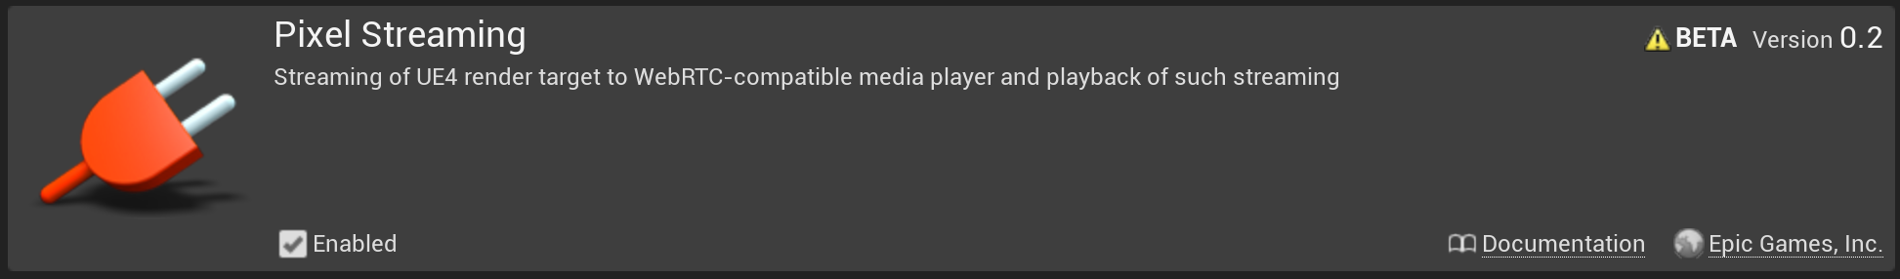

Figure

1. **Package the application**

The Pixel Streaming Plugin only works when the application has been packaged as a standalone executable file, so the next step is to package this car configurator application for windows, the author’s operating environment.

1. **Add the audio mixer**

In order to let the audio properly stream, the audio mixer is required. A new shortcut of the executable file is created and the text -*AudioMixer -PixelStreamingIP=localhost -PixelStreamingPort=8888* is appended at the end of the *Target* field. Now the standalone application has been prepared to stream its rendered frames.

1. **Start the server and the packaged application**

Inside the the Unreal Engine installation folder, the Signaling Server can be started by running the *run.bat* file. What this will do is downloading the required things using NPM and setting up the server. Remember that Node.js is required for the server to work.

When the server has started correctly, the following lines will appear in the console window (Figure). All these ports are configurable in the documentation.

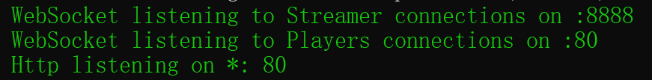

Figure

The packaged car configurator application is started from the shortcut created before. When this application connects to the Signaling and Web Server, the following line (Figure) appears in the console window. It means that the application runs successfully with the enabled Pixel Streaming Plugin and the Signaling and Web Server is ready to connect the client to this application.

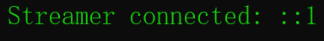

Figure

1. **Connect clients**

Now the web browsers on different devices can be connected to this car configurator application.

**4.6.2 Remote Pixel Streaming**

To run the application with Pixel Streaming Plugin over the open network, the TURN and STUN Server are needed. The first two of the steps is the same in section 4.6.1. So this section will start from the fourth step.

1. **Add the audio mixer**

The shortcut of the executable file still needs to be created. But the added text becomes -A*udioMixer -PixelStreamingIP={publicIP} -PixelStreamingPort=8888*. The Pixel Streaming IP should be the public IP of the computer that is running the Unreal Engine application instead of the *localhost*. Because this time the application is played on the open network.

1. **Start the server and the packaged application**

Instead of start *run.bat* directly, the names of the TURN and STUN Server are required to set first. In the folder where the Signaling Web Server is placed, find the following document (Figure) and set the name of the TURN and STUN Server in the *peerConnectionOptions* option (Figure). Then run *runAWS_WithTURN.bat* to start the server.



Figure

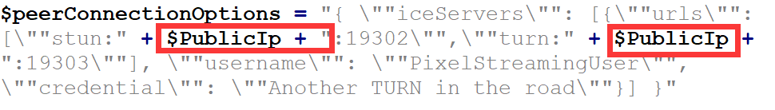

Figure

1. **Connect clients**

To connect

**4.6.3 Connection Results**

Still need to add…

**Chapter 5**

**Discussion**

This chapter discusses the results and the performance of the streaming application presented in Chapter 4. The first section presents the usability which is evaluated through interviews with users from three different career fields. This chapter will additionally discuss the comparison between Pixel Streaming and other distribution solutions, such as WebGL and HTML5, and finally give the reasons for developing Pixel Streaming.

**5.1 Consideration of Usability**

The handling and user-friendliness of the car configurator application and the streaming technology were perceived as overall pleasant as seen in Figure 6-1. All the interviewees found the application easy to use, although some participants found it at the beginning slightly less easy due to their inexperience with… But once all functionalities have been learned, the application was referred to as “very user-friendly”. Additionally, everybody received a good sense of orientation by checking the menu. In conclusion, the PS application was considered as user-friendly and comfortable to use.

Degree of user-friendliness

1. The application is easy to use.
2. The application provides a good overview of the functionalities.
3. The application provides a good orientation.

Figure 5-1: Degree of user-friendliness of the PS application accessed using a five-tier Likert scale

(Strongly Agree, Agree, Neutral, Disagree. Strongly Disagree)

**5.2 Comparison of Distributed Solutions**

Here two other solutions WebGL and HTML5 for distributing content are described. Then their limitations will be discussed. At last, the reason for choosing Pixel Streaming is given.

**5.2.1 WebGL**

WebGL is a cross-platform JavaScript API that is implemented right into the web browser. Users can interactive with the 2D or 3D graphics rendered in the HTML5 Canvas element in browsers that support it without downloading an application or plugin.

WebGL is based on OpenGL ES (OpenGL for Embedded Systems) that supports for embedded systems like smartphones, tablets, video game consoles, and so on. [白皮书] It is executed on a computer’s Graphic Processing Unit (GPU). WebGL elements can be composited with other HTML elements, allowing GPU-accelerated usage of physics and image processing and effects [19].

To employ WebGL, both source code written in JavaScript and shader code written in OpenGL ES Shading Language (OpenGL ES SL) are required. [白皮书] Compiling is not needed before deployment.

**Limitations**

The main limitations of WebGL, when considered as a broad distribution tool, have to do with content creation and delivery. Content has to be produced specifically to work in the OpenGL ES SL shader language, which in its current state is usable only for interactive web deployment of applications. To deploy content created with a real-time engine like Unreal Engine, the content and interactive elements must be set up to work within the WebGL framework.

In addition, WebGL relies entirely on the capabilities of the receiving browser and hardware on the client side; the quality of the graphics depends on the browser’s display capabilities. Data must be downloaded to the client side, and the time to download defines the wait time for the start of the experience. For a complex experience with a large dataset, the client must have sufficient space to store the data.

If the data is sensitive or confidential, additional steps are required to secure it on the client side.

In a wider platform perspective, this requires the system to maintain at least two data sets, shader models, and creative setups when working with different end channels.

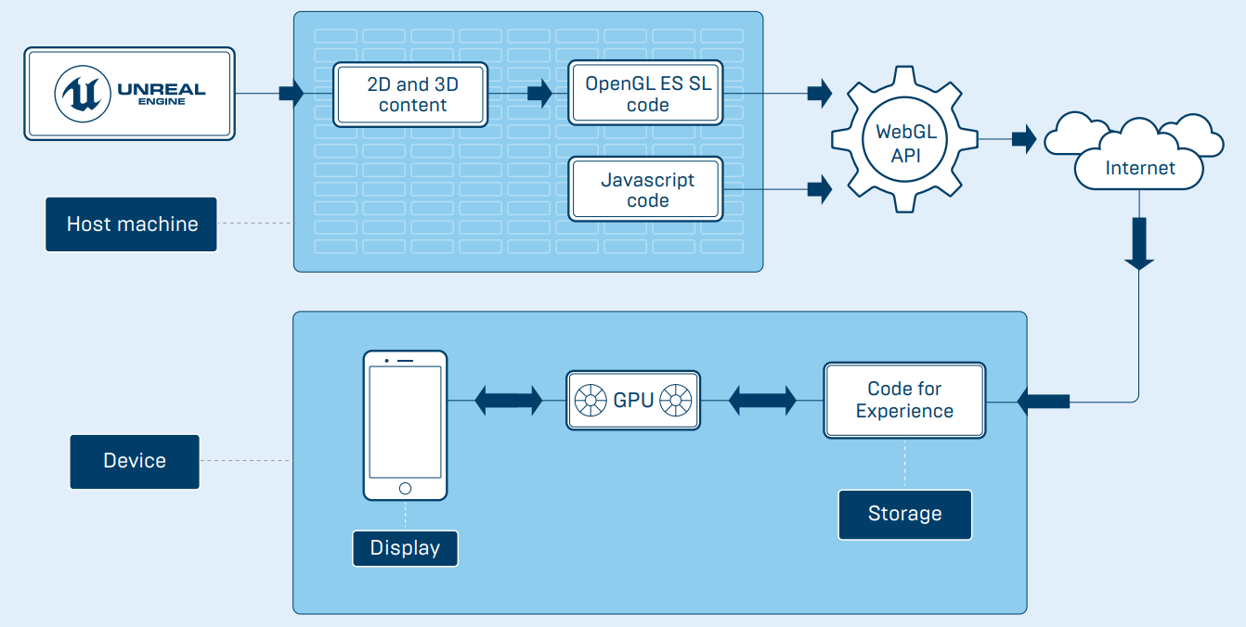

Figure Dataflow of WebGL Deployment

Despite its limitations, WebGL is a very simple deployment option suitable for experiences with small datasets, low security concerns, and basic quality requirements.

WebGL is inexpensive when deploying in current host environments, and might be enough for simple use cases. Epic is working on a WebGL exporter for Unreal Engine, but it will be suitable only for simple implementations.

**5.5.2 HTML5**

HTML5 is the latest version of HTML, the markup language for web page development. There are various solutions within HTML5 itself to build 3D experiences with the Canvas element, and without using WebGL at all. All these solutions require some knowledge of GPU programming and the packaging of extensive data for the end client to download, and result in an experience limited in quality and functionality.

**Limitations**

This setup runs the application on the client hardware, which requires the client to download the entire dataset before the experience can start. Download speed and available space are key factors in such a deployment—for a rich experience, the client might need to download several GB of data, which is not feasible with regard to wait time and storage space, particularly on mobile devices.

As with WebGL, this methodology requires the system to maintain two data standards, and can’t guarantee a consistent user experience between the original content and the distributed content. Distributed content can be updated and maintained only by completely replacing it, which can become troublesome with highly variable content. Concerns about security with HTML5 are the same as those for WebGL.

HTML5 solutions are already at the limit of providing benefits, and development in this area is not headed toward commercial use. The deployment of these variations will depend on custom development with tight focus on the target use case and application.

**5.2.3 Reasons for Pixel Streaming**

**Chapter 6**

**Conclusion and Outlook**

Potential Applications